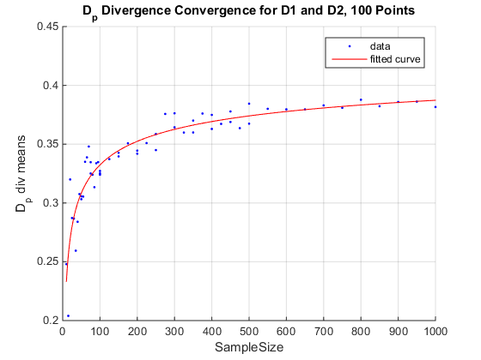

c = 0.4559 (0.38, 0.5319) 10000

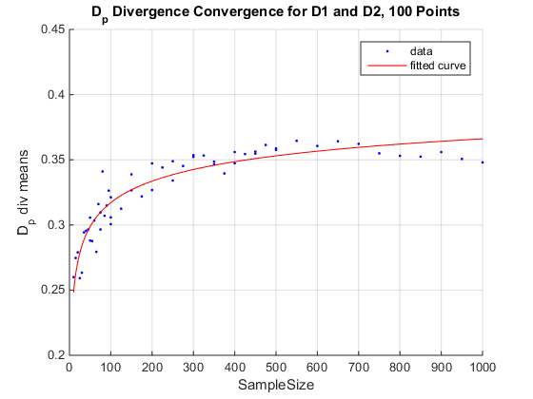

c = 0.4875 (0.3074, 0.6675) 1000